  www.nps.gov.wales
  tel 0300 7900 170
  nationalprocurementservice@wales.gsi.gov.uk



March 2016

  
  Contents
  1. Introduction
  2. News
  3. Forward Look
  4. Current and upcoming activity
  5. Savings

1. Introduction

Welcome to the March edition of the NPS Newsletter.
This month, NPS and Value Wales were recognised at the Government Opportunities Excellence in Public Procurement Awards. Full details can be found in the news section below.
NPS is now planning the first phase of a programme of aggregated mini-competitions for a selected range of NPS Frameworks. These are planned to take the burden of running mini-competitions away from customer organisations, and drive improved savings. Specific details will be shared with customers shortly.

2. News

Success at the GO Awards
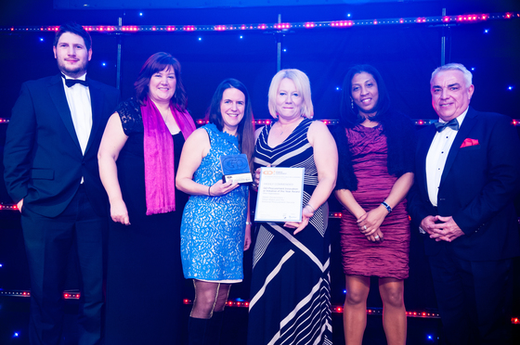

On Tuesday 8 March, NPS and Value Wales were recognised at this year's Government Opportunities Excellence in Public Procurement Awards. Our collaborative work on the Joint Bidding Guide received a 'Highly Commended' Award in the 'GO Procurement Innovation or Initiative of the Year Award - Other Organisations' category.

The Joint Bidding Guide is designed to make it easier for consortia to compete for, and win, public sector contracts. Much of the delivery of Joint Bids has been undertaken by Fleet colleagues. Thank you to all who supported the Joint Bidding concept and made it such a success.

The Government Opportunities (GO) Excellence in Public Procurement Awards recognise and reward excellence and achievement in the procurement sector and for the past 16 years have been the benchmark by which progress in commissioning, procurement and public service delivery has been measured. Congratulations to all winners and nominees.

A full list of winners, can be found on the GoAwards website.

Employee Benefit Schemes Framework Launch Event
The first customer launch event for the Employee Benefit Schemes Framework was held in the Waterton Centre, Bridgend on 10 February.

The Managed Service Provider iCOM Works Ltd and a number of their specialist partners were on hand, offering advice and demonstrations of the various Salary Sacrifice Schemes on offer through the Framework. These include:
- childcare voucher scheme
- cycle to work scheme
- car scheme
- mobile phone and technology scheme
- annual leave purchase scheme
- workplace parking scheme
- travel to work scheme
- health screening scheme
- personal learning scheme
The next event will take place in Welsh Government Offices, Llandudno Junction on Friday 18 March. Please contact NPSPeopleServices&Utilities@wales.gsi.gov.uk if you wish to discuss the Framework or attend the event.

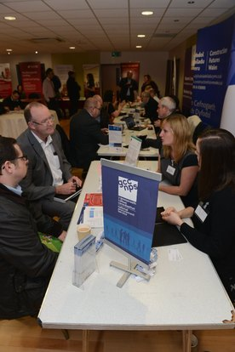 |  | RCT Meet the Buyer Event  Businesses looking to network and secure new contracts enjoyed the eighth annual Meet the Buyer Event in February.  NPS were present at the annual event, which is organised by Rhondda Cynon Taf Council’s Procurement Service. The event brings together key businesses, public sector buying organisations and industry experts to offer advice, support and a valuable networking opportunity.  Thank you to all the businesses that came to visit us on the NPS stand to discuss current and upcoming opportunities. If you would like to find out more about our current and upcoming framework agreements/contracts, please visit our website.  A total of 216 people from 162 organisations attended the event.

3. Forward Look

To ensure we give both buyers and suppliers as much advance notice of NPS events as possible, we have created the following Forward Look table. Please contact the relevant category mailbox for further information, and remember to keep an eye on the NPS Twitter and LinkedIn pages and Sell2Wales for event announcements.

Supplier events
If you are aware of a supplier that may be interested in any of these events, please let them know.

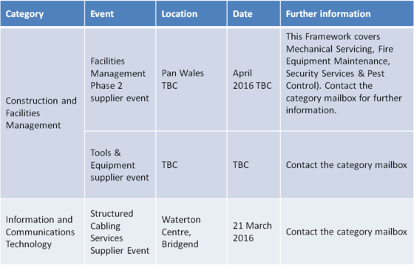

Buyer events
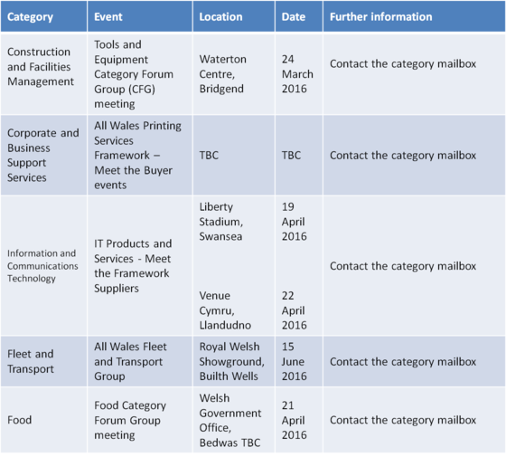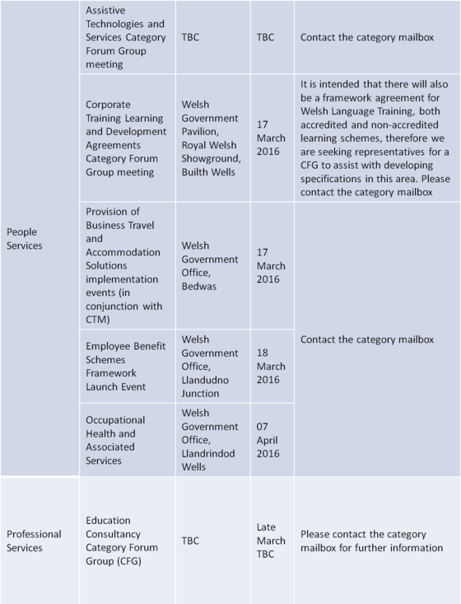

For further information on the above events, please contact the corresponding category mailbox below:

Construction and Facilities Management
Corporate and Business Support Services
Fleet and Transport
Food
Information and Communications Technology
People Services and Utilities
Professional Services

4. Current and upcoming activity by category

There are a number of Prior Information Notices and Contract Notices listed below. All will be advertised through Sell2Wales, however please share this information with as many suppliers as possible if you think they would be interested.
If you would like further information, please contact the relevant team by e-mail.

Construction and Facilities Management  Prior Information Notices  - Hand Tools, Plant and Equipment - issued 4 March 2016.  Updates  - Timelines have been reviewed and head line details for amended start dates are as follows:  - Construction Equipment: Hand Tools, Hire & Equipment Purchase - Week commencing 29 August 2016  - Construction Equipment: Plant & Equipment Purchase and Hire - Week commencing 3 October 2016  Contact: NPSConstruction&FM@wales.gsi.gov.uk |  | 

Corporate and Business Support Services

Contract Notices
- Postal and Courier Services & Mailroom Equipment Framework - issued 10 February 2016. Deadline for submissions 22 March 2016.

Category Forum Group (CFG) Outcome Reports
- Stationery and Paper CFG Outcomes Report now available on the Sell2Wales website.

Updates
- Supply of High Visibility and Personal Protective Equipment (PPE), Uniforms, Workwear and Leisurewear - we are currently at evaluation stage. Sampling events will be arrange for end of March/early April. If you would like further information, please contact the mailbox below.

Contact: NPSCorporateServices@wales.gsi.gov.uk

Fleet and Transport

Updates
- Tyres - NPS will continue to coordinate collaborative mini-competitions. Customers should contact the mailbox below if their organisation wishes to take part in these mini-competitions. Not only is NPS trying to take the burden of the mini-competition from customers, but the aggregated commitment is expected to improve results.
- Fuel Cards - NPS undertook a Further Competition against the Crown Commercial Service Framework Agreement for Fuel Cards and Associated Services Ref: RM1027. Any customer wishing to make use of the terms agreed under the mini-competition, please contact the mailbox below.
- Vehicle Spares - A successful Joint Bidding event was held on 11 March 2016, with suppliers who expressed an interest in forming a consortia to respond to the forthcoming tender. A further Category Forum Group meeting is being planned during March/April. Stakeholder representatives will be notified as soon as possible.
- Timelines have been reviewed and head line details for amended start dates are as follows:
- Vehicle Spares - Week commencing 3 October 2016
- Driver Licence Checks - Week commencing 1 August 2016

Contact: NPSFleet@wales.gsi.gov.uk

 |  | Food  Contract Notices  - Supply of Sandwiches and Sandwich Fillings - issued 7 March 2016. Deadline for responses 23 March 2016.  Upcoming Contract Notices  - Supply of Frozen Plated Meals - due to be issued w/c 21 March 2016.
Updates
- The Food Timelines have been reviewed and head line details for amended start dates are as follows:
- Prepared Sandwiches and Sandwich Fillings - 4 May 2016
- Frozen Plated Meals - 25 May 2016
- Soft Drinks, Crisps, Snacks and Confectionery - 29 June 2016
- Grocery, Frozen Foods and Provisions - 3 August 2016
- Bread, Rolls, Cakes and Associated Products - 24 August 2016
- Alcoholic Beverages - 24 August 2016
Organisations are asked to ensure that they make necessary localised arrangements for continuity of supply.

Contact: NPSFood@wales.gsi.gov.uk

Information and Communications Technology

Contract Notices
- Structured Cabling Services - issued 11 March 2016. Deadline for submissions - 11 April 2016.

Upcoming Contract Notices
- Information Assurance Services - due to be issued in March within the Notices section on Sell2Wales.
- Digitisation, Storage and Disposal - due to be issued in March. This will be a Reserved Dynamic Purchasing System (DPS). Eligible businesses as described under Article 20 of the Public Contracts Regulations 2015 will be invited to apply for inclusion on the DPS for the following two lots:
Lot 1 - Digitisation, Storage and Disposal of Records
Lot 2 - ICT Asset Disposal, Recycling and Re-use

Updates
- We will be issuing a questionnaire to customer organisations to obtain feedback to begin mapping the next phases of the ICT Pipeline. If organisations would like to check that we have the correct contacts, please contact the ICT mailbox below.
- MFDs has recently moved from the Corporate and Business Support Services category to the ICT Category. Engagement regarding the delivery of this requirement will commence in March.
- Timelines have been reviewed and head line details for amended start dates are as follows:
- Structured Cabling Services - there are delays and we will notify customers of new dates as soon as possible.
- Digitisation, Storage and Disposal - Week commencing 13 June 2016

Contact: NPSICTCategoryTeam@wales.gsi.gov.uk

People Services and Utilities

Upcoming Contract Notices
- Provision of Waste Disposal Bags - due to be issued in March.
- Welsh Language Training - due to be issued in March.
- Corporate Training, Learning & Development, Phase 1 - due to be issued in April.

Contact: NPSPeopleServices&utilities@wales.gsi.gov.uk

Professional Services

Updates
- We've already received a great response to the possibility of the NPS providing NEC 3 Professional Services Contract awareness training. There's still time to register your interest in attending these courses. Please contact Kathryn Jones through the mailbox below.

Category Forum Groups (CFG) - Call for representatives
- Barristers Services - we have met with a number of Heads of Legal teams throughout January and February to secure representation on our CFG, which has been established to provide organisations the opportunity to feed into the Barristers Services tender process. However; we would very much welcome additional engagement and should anyone wish to meet to discuss further, please contact the mailbox below.

Contact: NPSProfessionalServices@wales.gsi.gov.uk

5. Savings
NPS is reporting a 4.82% savings rate this financial year against total spend through Contracts and Framework Agreements under management. This includes additional negotiated savings and on-boarded agreements.
The overall total savings equate to £3,542,187 from 1st April 2015 – 31st December 2015.
If you require further clarification of these savings, please contact your NPS Sector Representative or your Head of Procurement.

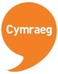 |  | Os hoffech dderbyn y cylchlythwr hwn drwy'r Gymraeg, neu i ddad-danysgrifio, e-bostiwch: Bethan.Williams13@cymru.gsi.gov.uk  If you would like to receive this newsletter in Welsh, or to unsubscribe, please e-mail: Bethan.Williams13@wales.gsi.gov.uk

